Issue 1 : Life Cycle Status : ‘Exception Use’ data is displayed as ‘UNKNOWN’ .

QA Query :

SELECT COALESCE(CONCAT('OT_LIFE_CYCLE_STATUS_C','~','PROCESSING_ACTIVITIES','~',upper(SRC.LIFE_CYCLE_STATUS)),'UNSPECIFIED') as Source_id,

LKP.row_id,SRC.LIFE_CYCLE_STATUS,LKP.dimension_name,Count(1) as CNT

FROM pandg_mdsdb.pg_mega_pgb_application_rita_final SRC

LEFT JOIN pandg_mdwdb.d_rita_application_c TRGT ON SRC.NAME=TRGT.row_id AND SRC.sourceinstance=TRGT.source_id

LEFT JOIN pandg_mdwdb.d_lov LKP ON

COALESCE(CONCAT('OT_LIFE_CYCLE_STATUS_C','~','PROCESSING_ACTIVITIES','~',upper(SRC.LIFE_CYCLE_STATUS)),'UNSPECIFIED')=LKP.row_id

AND SRC.sourceinstance=LKP.source_id

group by 1,2,3,4;

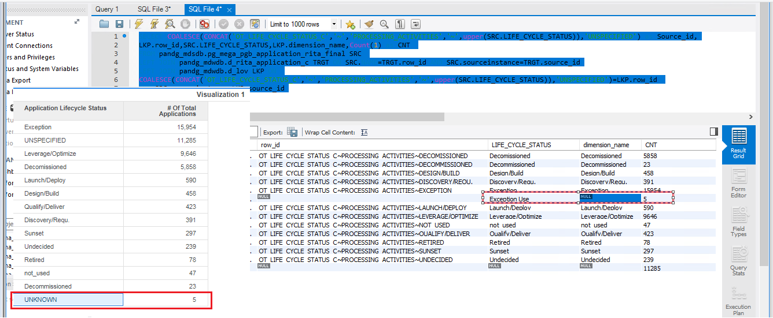

Fixed and Working fine :

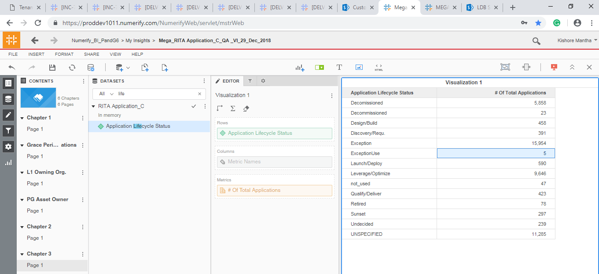

Issue 2: Data mismatch for the ‘Grace Period Start Date’ between Source and Cube.

SELECT CASE WHEN SRC.APPLICATION_NATURE IN ('Generic','XOApplication','NonDigital','Component')

AND SRC.LIFE_CYCLE_STATUS NOT IN ('Decomissioned','Exception Use','not_used','Undecided')

AND TRGT.gdpr_relevant_c_flag ='Y'

AND level1.LVL1_ORG_NAME IN

('Information Security','IT Consumer Solutions','IT Customer Solutions & Delivery','IT Data & Analytics Organization','IT IT Development Organization',

'IT IT Innovation Organization','IT Solutions','Consumer Services','FSS','IDQ','MANAGEMENT SERVICES','Master Data Organization','MY PG SERVICES','PS Shared Services & Technology Operations','PTW')THEN COALESCE(TRGT.grace_period_start_date,CONVERT_TZ(OD.lastupdated,'GMT','America/New_York'))

ELSE NULL END AS Source_Grace_Period_Start_Date,TRGT.grace_period_start_date,Count(distinct SRC.NAME) as Application_Count

FROM pandg_mdsdb.pg_mega_pgb_application_rita_final SRC

LEFT JOIN pandg_mdwdb.d_rita_application_c TRGT ON SRC.NAME=TRGT.row_id AND SRC.sourceinstance=TRGT.source_id

LEFT JOIN (select source_id,max(lastupdated) as lastupdated from pandg_mdwdb.o_data_freshness

group by source_id) OD ON TRGT.source_id=OD.source_id

LEFT JOIN

(SELECT a.app_hexid,a.sourceinstance,

CASE WHEN Count(1) <= 1 THEN MAX(COALESCE(a.responsible_org_unit_hexid,'UNSPECIFIED')) ELSE 'UNKNOWN' end as responsible_org_unit_hexid

FROM pandg_mdsdb.pg_mega_pgv_app_responsible_org_person_final a WHERE a.pg_development_org = 'Y' AND a.app_hexid IS NOT NULL

group by a.app_hexid,a.sourceinstance) SRC1 ON (SRC.NAME=SRC1.app_hexid AND SRC.sourceinstance=SRC1.sourceinstance )

LEFT JOIN pandg_mdsdb.pg_mega_pgv_org_itam_gbs_final level1

ON (SRC1.responsible_org_unit_hexid=level1.LVL1_ORG_HEX OR SRC1.responsible_org_unit_hexid=level1.LVL2_ORG_HEX

OR SRC1.responsible_org_unit_hexid=level1.LVL3_ORG_HEX)

AND SRC1.sourceinstance=level1.sourceinstance

group by 1,2;

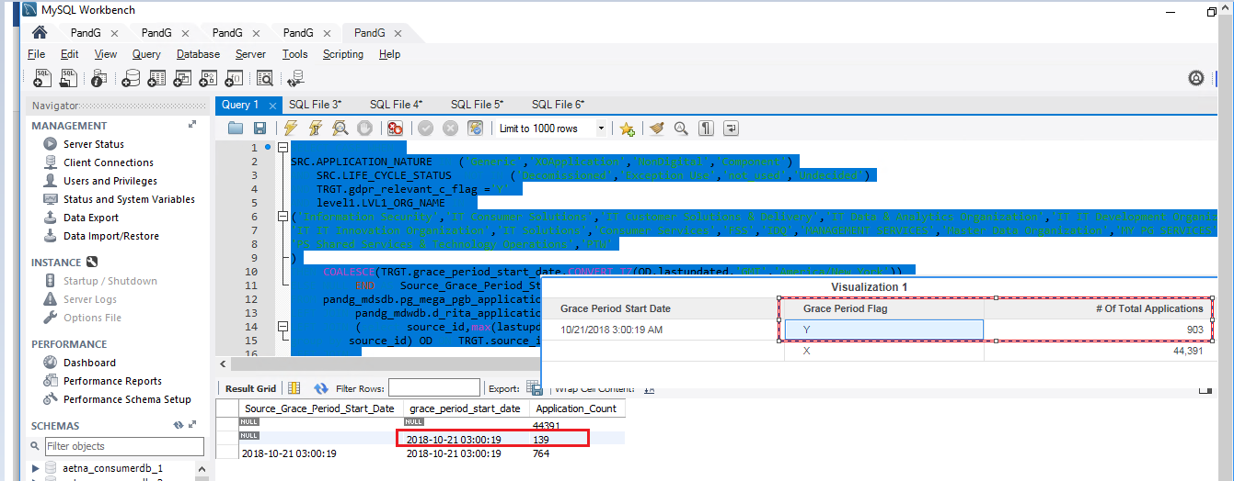

The ‘Grace Period Start Date’ is displayed as NULL even all the conditions are Met.

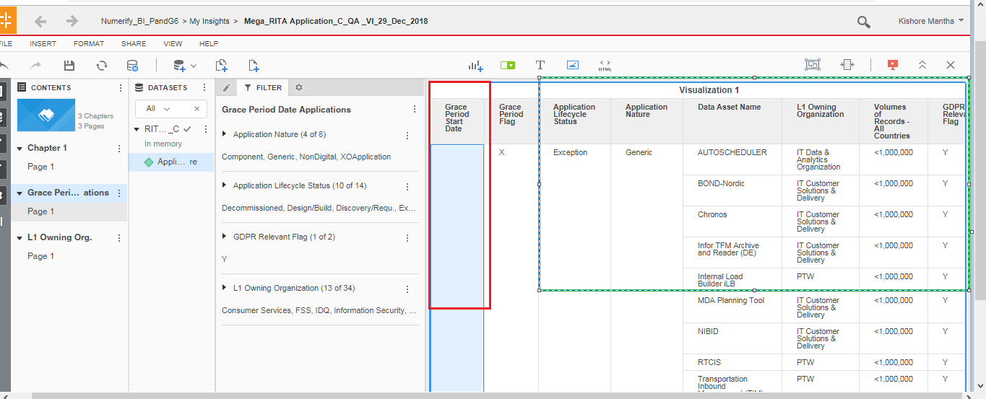

Issue 3: SRC.TOTAL_3RD_PARTY_WITH_ACCESS : ‘>=1,000 - <20,000’ is moved to UNKNOWN in the d_lov.

SELECT SRC.TOTAL_3RD_PARTY_WITH_ACCESS,LKP.dimension_name,

Count(1) as CNT

FROM pandg_mdsdb.pg_mega_pgb_application_rita_final SRC

LEFT JOIN pandg_mdwdb.d_rita_application_c TRGT ON SRC.NAME=TRGT.row_id AND SRC.sourceinstance=TRGT.source_id

LEFT JOIN pandg_mdwdb.d_lov LKP ON

COALESCE(CONCAT('OT_THIRD_PARTY_USERS_C','~','PROCESSING_ACTIVITIES','~',upper(SRC.TOTAL_3RD_PARTY_WITH_ACCESS)),'UNSPECIFIED')=LKP.row_id

AND SRC.sourceinstance=LKP.source_id

group by 1,2;

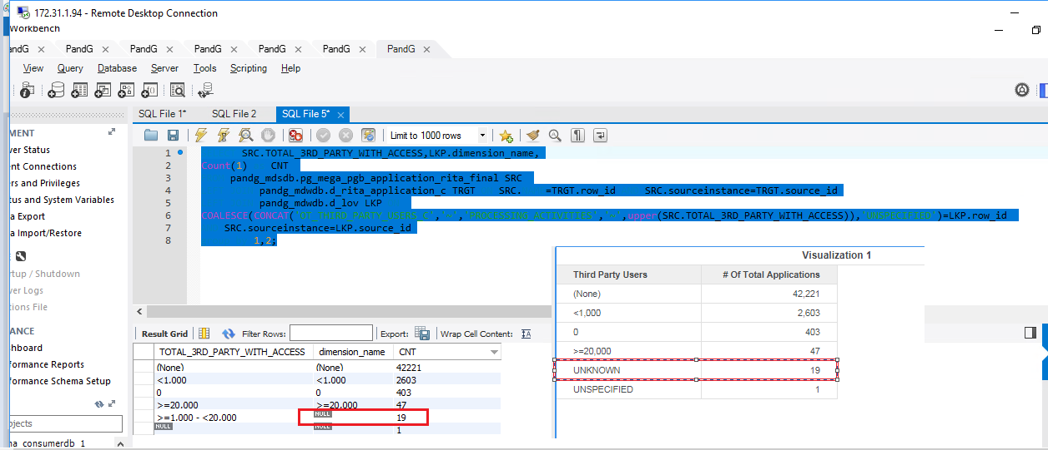

Fixed and Working fine :

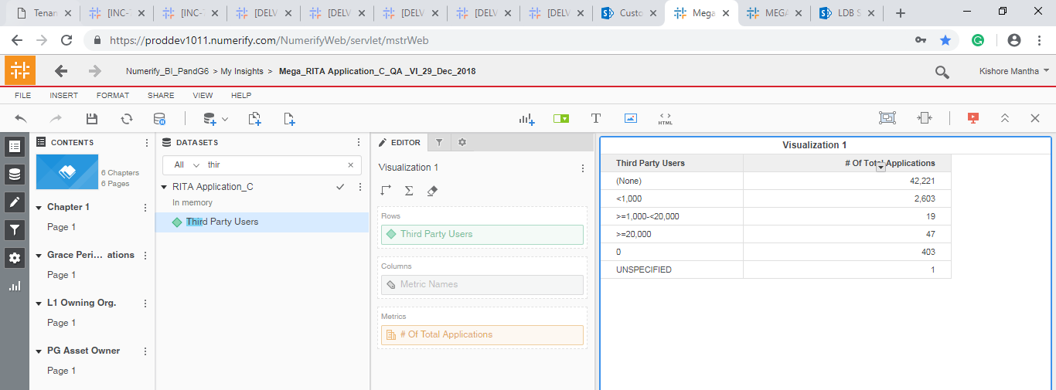

Issue 4: TOTAL_PG_PERSONNEL_WITH_ACCESS, ‘>=1,000 - <20,000’ is displayed as ‘UNKNOWN’

SELECT SRC.TOTAL_PG_PERSONNEL_WITH_ACCESS,LKP.dimension_name,

Count(1) as CNT

FROM pandg_mdsdb.pg_mega_pgb_application_rita_final SRC

LEFT JOIN pandg_mdwdb.d_rita_application_c TRGT ON SRC.NAME=TRGT.row_id AND SRC.sourceinstance=TRGT.source_id

LEFT JOIN pandg_mdwdb.d_lov LKP ON

COALESCE(CONCAT('OT_PG_USERS_C','~','PROCESSING_ACTIVITIES','~',upper(SRC.TOTAL_PG_PERSONNEL_WITH_ACCESS)),'UNSPECIFIED')=LKP.row_id

AND SRC.sourceinstance=LKP.source_id

group by 1,2;

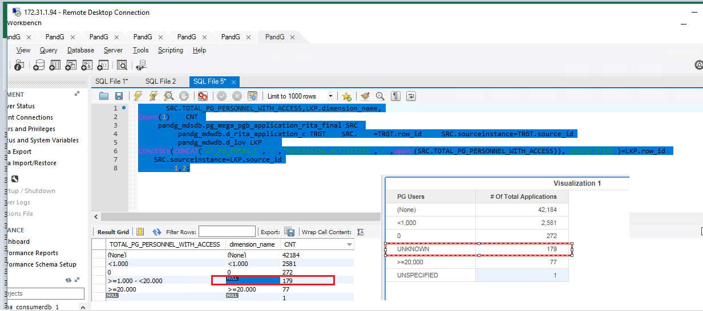

Fixed and Working fine:

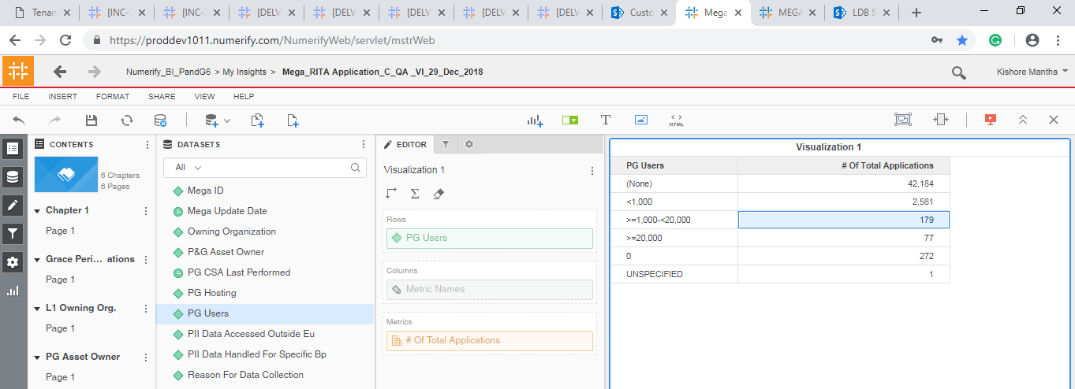

Fixed and Working fine :

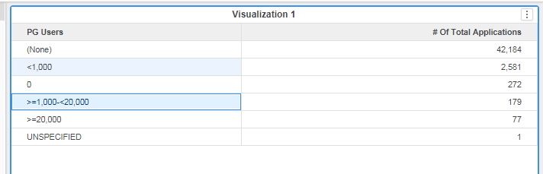

Issue 5:

Few L1 Owning Organizations are not displayed in Cube:

Ex: IT IT Development Organization and IT IT Innovation Organization

New Issues on 2-Jan-2018:

Issue 6:

Data mismatch between source and cube for certain ‘Retension_Span_Year’ :

SELECT

COALESCE(SRC.RETENTION_SPAN_YEARS,'UNSPECIFIED'),

Count(SRC.NAME) as CNT

FROM pandg_mdsdb.pg_mega_pgb_application_rita_final SRC

LEFT JOIN pandg_mdwdb.d_rita_application_c TRGT ON SRC.NAME=TRGT.row_id AND SRC.sourceinstance=TRGT.source_id

group by 1;

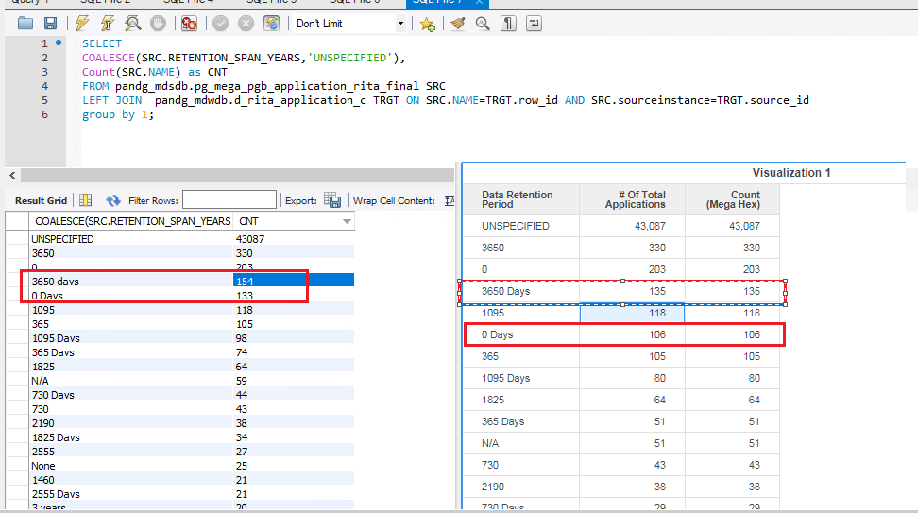

Issue 7: ‘Description’ field is displayed instead of ‘PG_CSA_Last_Performed’ Date :

SELECT SRC.SHORT_NAME,

COALESCE(date_format(substring(replace(SRC.PG_CSA_LAST_PEFORMED,' ',''),1,14),'%Y-%m-%d %h:%i:%s'),

''),TRGT.pg_csa_last_peformed,

Count(1) as CNT

FROM pandg_mdsdb.pg_mega_pgb_application_rita_final SRC

LEFT JOIN pandg_mdwdb.d_rita_application_c TRGT ON SRC.NAME=TRGT.row_id AND SRC.sourceinstance=TRGT.source_id

group by 1;

